Maejo Int. J. Sci. Technol. 2017, 11(03), 211-218
Maejo International
Journal of Science and Technology

ISSN 1905-7873
Available online at www.mijst.mju.ac.th
Technical Note
Caffeine and catechins in fresh coffee leaf (Coffea arabica) and coffee leaf tea
Sujitra Ratanamarno^{1, 3, *} and Sunate Surbkar^{2, 3}

¹Postharvest Technology, Faculty of Engineering and Agro-Industry, Maejo University,
Chiang Mai, Thailand
²Agricultural Engineering, Faculty of Engineering and Agro-Industry, Maejo University,
Chiang Mai, Thailand
³ Postharvest Technology Innovation Centre, Commission on Higher Education, Bangkok, Thailand
* Corresponding author, e-mail: sujitrarat@gmail.com

Received: 27 June 2017 / Accepted: 24 September 2017 / Published: 26 September 2017

Abstract: Caffeine and some catechins in coffee leaves were preliminarily investigated. To make coffee leaf tea, coffee leaves were roasted for 6 min. at 100±10 ^{๐}C and then rolled by hand. Young leaves were roasted again at 100±10 ^{๐}C for 1 hr and 15 min. or until the leaves were dry and crispy. For mature leaves, they were roasted further for 1 hr without rolling. To make fermented coffee leaf tea, both fresh young and mature leaves were crumbled and fermented for 8 hr and then roasted. Caffeine and catechins were determined by HPLC. The following results were obtained for fresh coffee leaves: caffeine, 1.8-3.2 mg/g; epigallocatechin gallate, 5.5-16.4 mg/g; epicatechin gallate, 0.26-0.48 mg/g; epicatechin, 0.27-0.40 mg/g; and catechin, 0.05-0.18 mg/g. The amounts of caffeine and catechins were found to be higher in young leaves than in mature leaves. For coffee leaf tea, a steeping time of at least 5 min. was suggested. It was also found that most of the phenolics were lower in fermented leaves than in non-fermented leaves.

Keywords: Coffea arabica, coffee leaf, coffee leaf tea, caffeine, catechins
_______________________________________________________________________________________

INTRODUCTION

Coffee leaf tea is a herbal tisane made from the leaves of Coffea robusta or Coffea arabica. This tea is from the same plant that produces beans used for ground coffee. The tasty infusion has been consumed in Ethiopia (known as Kuti) for over 200 years. Sumatrans also drink coffee leaf tea rather than coffee from roasted beans because they believe the former is more nutritious. However, coffee leaf tea does not taste like coffee at all. The taste is found to be herbaceous and earthy with sweet grassy notes in the background [1]. Coffee leaf tea may have an even higher concentration of antioxidants and other healthy components than do some true teas made from the tea plant, Camellia sinensis. Many species of coffee plant have high levels of mangiferin in their leaves; the Arabica coffee leaves were found to contain the highest levels of mangiferin, which was claimed to possess anti-inflammatory effects, reduce the risk of diabetes and blood cholesterol, and protect neurons in the brain [2].
Caffeine, a plant alkaloid, has recently attracted much scientific and public attention owing to its stimulatory effects [3]. Popular beverages such as coffee and true tea contain certain amounts of caffeine: about 74 mg/cup (237 mL) and 15 mg/cup respectively [4]. In coffee seedlings caffeine is distributed mainly in leaves and cotyledons, and essentially no caffeine was detected in roots or older brown parts of shoots [5]. It has been proposed that caffeine is sequestered in the vacuoles of coffee leaves as a chlorogenic acid complex [6]. Young leaves that have not fully expanded have the highest content of caffeine [7]. It was also found that the caffeine content in coffee leaves with balanced mineral nutrition was 21.9 g/kg dry weight [8]. Ashihara et al. [9] reported the caffeine content in coffee leaves (fresh weight): buds, 5.7 mg/g; young leaves, 7.1 mg/g; mature leaves, 2.1 mg/g; and aged leaves, 2.4 mg/g. Although coffee leaf tea (antioxidant content: 11.20 µmoles Trolox equivalent/mL of tea; caffeine content: 12 mg/250 mL) has been introduced into the market as a new beverage in Canada since 2015 [10], to our knowledge no data on the catechins content have been reported in the literature.
It has been shown that tea confers beneficial effects to the health of consumers, including the reduction of cholesterol, depression of hypertension, anti-oxidation effect, anti-microbial effect, and protection against cardiovascular disease and cancer [11]. Polyphenols, especially catechins, are considered to have the main roles in these beneficial effects on human health [12]. The major tea catechins are (—)-epigallocatechin gallate, (—)-epigallocatechin, (—)-epicatechin gallate and
(—)-epicatechin [12].
In this study it is aimed to preliminarily investigate the presence and amounts of caffeine and catechins in fresh coffee leaves and coffee leaf tea. The effects of steeping time and fermentation of leaves on caffeine and catechins content are also investigated.

MATERIALS AND METHODS

Plant Materials

Leaves were harvested from organic coffee plants (Coffea arabica), 8-9 years old, growing under natural environment in Fang district, Chiang Mai province (altitude 479 m, 19^{๐} 55‘ 8‘‘ N/
99^{๐} 12‘ 49‘‘ E), Thailand. The developmental stages of the leaves were categorised as: 1) buds and young leaves (1st-4th leaves, 3-4 weeks after emergence), which are yellow-green (Figure 1a), and 2) mature leaves (5th-8th leaves, 5-6 weeks after emergence), which are more expanded and of darker green (Figure 1b). The variation in time for each stage depends upon season.

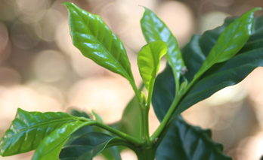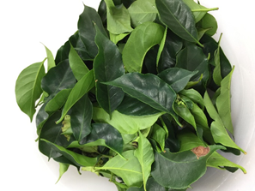
(a) (b)
Figure 1. Coffee leaves: (a) buds and young leaves; (b) mature leaves

Coffee Leaf Processing

Young and mature coffee leaves were picked and sorted, washed with tab water and air-dried. One hundred grams of young leaves were roasted at 100±10 ^{๐}C in a rotary roaster for 6 min. or until the leaves were soft and rollable. The young roasted leaves were then rolled by hand, and after rolling they were roasted again at 100±10 ^{๐}C for 1 hr and 15 min. or until the leaves were dry and crispy (Figure 2a). For mature leaves, 100 grams of leaves were roasted at 100±10 ^{๐}C for 1 hr or until the leaves were dry, crispy and loose without hand rolling since the leaf blades were too thick (Figure 2b).
For fermented coffee leaves, both fresh young and mature leaves were crumbled for a few minutes and put in air-tight plastic bags for 8 hr. The fermented leaves were then roasted in a rotary roaster at 100±10 ^{๐}C until the leaves were dry and crispy. All the processed leaves were kept in
air-tight plastic bags and stored in a cool, dry place (25-28 ^{๐}C, 60 %RH) for further analysis within 2 weeks.

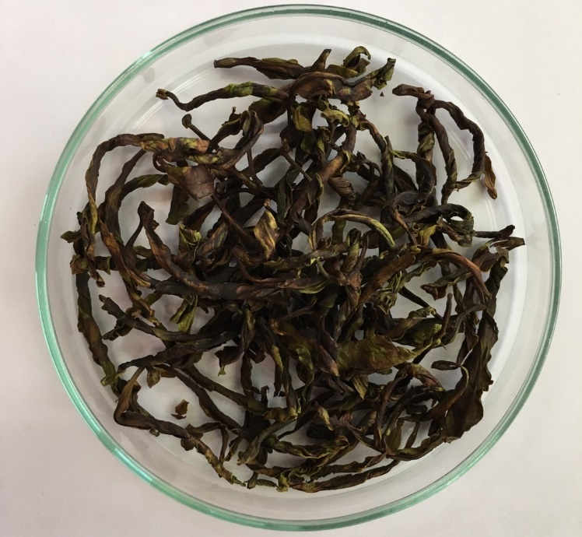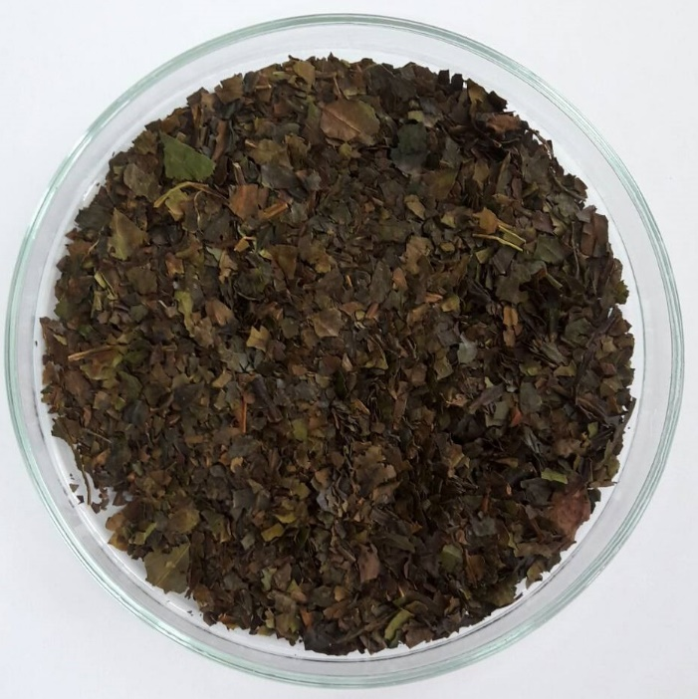
(a) (b)
Figure 2. (a) Roasted young coffee leaves; (b) roasted mature coffee leaves
Determination of Caffeine and Catechins

To determine the relative amounts of caffeine and catechins in fresh coffee leaves, young or mature leaves (1 g) were cut into small pieces and brewed in 100 mL of hot water (80±2°C) for
5 min. To compare steeping time, roasted young coffee leaves (1 g) were cut into small pieces and brewed in 100 mL of hot water for an allotted time, i.e. 5, 10 or 15 min. To compare the caffeine and catechins content of fermented and non-fermented coffee leaves, each sample (1 g) of roasted coffee leaves (young or mature, fermented or non-fermented) was cut into small pieces and brewed in 100 mL of hot water for 5 min. One mL of each prepared sample was filtered through a 0.45-µm nylon membrane filter (Nylon membrane, Filtrex, Singapore) and the filtrate kept in a 2-mL vial, wrapped with aluminum foil to protect from light and stored in the refrigerator (4°C). Each sample was analysed in triplicate.
The determination of caffeine and catechins was performed with high performance liquid chromatography (HPLC) according to the method of Oliveira [13] with some modifications. The HPLC (Shimadzu Corp., Japan) consisted of a UV/VIS detector (model SPD-20A), a column oven (model CTO-10AS VP), a pump (model LC-20 AD) and a degasser (model DGU-14AM), and fitted with an Inersil ODS-3 column (5 µm, 4.6 x 150 mm). The column temperature was maintained at 45°C, the flow rate was 1.5 mL/min. and the injection volume was 20 µL. Solvent A, 10 mM sodium phosphate buffer pH 2.6 (from ortho-phosphoric acid 85%, Merck, Germany and sodium dihydrogen phosphate monohydrate 99%, Merck, Germany), and solvent B (99.9% acetronitrile, RCI Labscan, Thailand) were the mobile phase for the gradient elution. A run time of 30 min. was set; solvent B was 7% from 0.01-15 min., 50% from 20-23 min. and 7% from 25-30 min.
Caffeine and catechins in coffee leaf tea were determined by linear equations of the mixed standard curves prepared from 0-100 µg/mL of standard caffeine, catechin, epigallocatechin gallate, epicatechin and epicatechin gallate (Sigma-Aldrich, USA), all diluted with deionised water (RCI Labscan, Thailand).
The data were analysed by using analysis of variance (ANOVA). Duncan’s multiple range tests (DMRT) were calculated to compare significant effects at p<0.05. All analyses were performed using Minitab 16 (©2013 Minitab Inc.).

RESULTS AND DISCUSSION

Figure 3 shows an example of HPLC chromatograms of coffee leaf tea in our study. The relative amounts of caffeine and catechins in young and mature coffee leaves is presented in Table 1. It was found that young leaves significantly (p<0.05) have higher amounts of both caffeine and catechins than do mature leaves. A similar result was reported by Fujimori and Ashihara [7], who found that young coffee leaves that are not fully expanded have the highest caffeine content. Ashihara et al. [9] also reported that buds and young leaves contain the highest concentration of caffeine with about one-third as much being detected in mature and aged leaves of coffee.
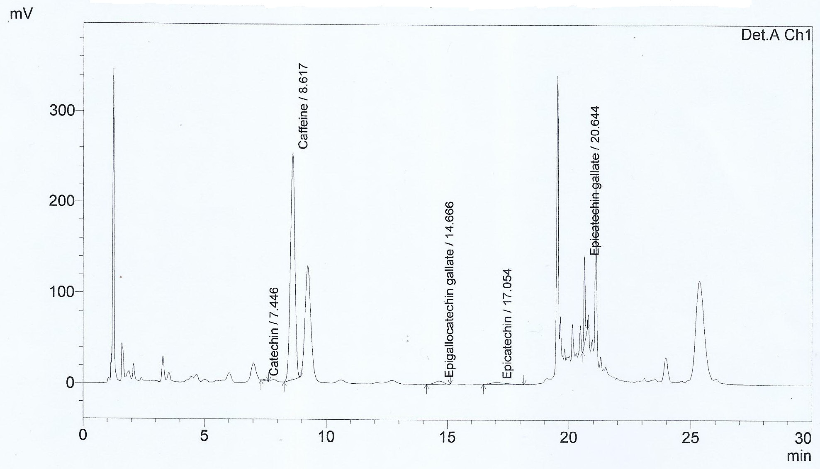

Figure 3. Sample of HPLC chromatograms of coffee leaf tea showing peaks of caffeine and catechins at 270 nm. (Numbers after compound names indicate retention times in minutes.)

Table 1. Caffeine and catechins from fresh coffee leaves

Sample | Caffeine (mg/g) | Catechin (mg/g) | Epigallocatechin gallate (mg/g) | Epicatechin (mg/g) | Epicatechin gallate (mg/g)
Young leaves | 3.2104±0.0035 ª | 0.1850±0.0173 ª | 16.3537±1.3048 ª | 0.3998±0.0113 ª | 0.4810±0.0307 ª
Mature leaves | 1.8006±0.1249 ^{b} | 0.0475±0.0035 ^{b} | 5.4752±2.0007 ^{b} | 0.2705±0.0122 ^{b} | 0.2657±0.0461 ^{b}

Notes: Values are expressed as means ± standard deviation (n=3).
Values in the same column followed by different letters are significantly different (p< 0.05).

It has been reported that caffeine biosynthesis from adenine and guanine only occurs in young coffee leaves whereas conversion of theobromine and caffeine occurs in mature and aged leaves [9]. Caffeine synthase activity therefore seems to be present in coffee leaves even after maturation. This is different from tea leaves, in which caffeine synthase activity disappeared after full development of the leaves [14]. It has been proposed that the synthesis of caffeine in buds and leaves of coffee plants is to prevent predation by animals [15]. In plants, caffeine and phenolics work as a natural defense system to deter insects and other herbivores with the bitter taste and stimulating qualities. Surprisingly, it is the vulnerable, growing buds and young leaves of tea and coffee plants that produce the highest amounts of caffeine [16].
Many factors affect the amount of caffeine in plucked tea and coffee leaves, which include the growing region, plant variety, plant age, duration of growing season, field conditions, soil nutrients, rainfall and stress by pests [16]. It was also shown that the position of leaves on the tea plant has an effect on the caffeine content. The youngest leaves at the top of the plant contain the highest amounts of caffeine and antioxidants [17].
The effects of steeping time of the young coffee leaf on caffeine and catechins content of coffee leaf tea are presented in Table 2. It was found that when a longer steeping time is used, a higher amount of caffeine and all catechins leaches out but there is no significant difference between 5- and 10-min. steeping times. The steeping time of 15 min. gave the highest extracted amounts of all the components with significant difference at p<0.05. In preparing coffee leaf tea, however, we suggested a steeping time of 5 min. to get the most preferable taste.

Table 2. Effects of steeping time of young coffee leaf on caffeine and catechins content of coffee
leaf tea

Steeping time (min.) | Caffeine (mg/g) | Catechin (mg/g) | Epigallocatechin gallate (mg/g) | Epicatechin (mg/g) | Epicatechin gallate (mg/g)
5 | 4.6831±1.3502 a | 0.3697±0.1088 a | 16.8661±4.0079 a | 1.3551±0.0756 a | 0.9089±0.1621 a
10 | 7.3205±1.7999 a | 0.4954±0.1009 a | 21.8598±5.3695 a | 1.4740±0.0695 a | 1.2087±0.1792 a
15 | 11.4421±0.6093 b | 0.8649±0.0869 b | 37.6950±7.2511 b | 1.7191±0.0794 b | 2.3986±0.5200 b

Notes: Values are expressed as means ± standard deviation (n=3).
Values in the same column followed by different letters are significantly different (p< 0.05).

The relative amounts of caffeine and catechins in different coffee leaf teas are presented in Table 3. Young, non-fermented coffee leaf tea has significantly higher amounts of caffeine, epigallocatechin gallate and epicatechin than young, fermented coffee leaf tea but the values for catechin and epicatechin gallate were not significantly different. Mature coffee leaf tea has higher amounts of catechin and epicatechin, whereas the values for caffeine, epigallocatechin gallate and epicatechin gallate are not significantly different. However, it is observed that most of the values for the catechins are lower in fermented leaves except those for epicatechin gallate and caffeine in mature, fermented coffee leaves although they are not significantly different. Mature leaf teas, both fermented and non-fermented, were found to have a higher amount of catechin than young, fermented or non-fermented leaf tea. This result does not match our previous results in Table 1 for fresh coffee leaves. The rolling process of young leaves, which induces oxidation, might have affected the catechin content. Oxidation may also be induced by the crumbling of fermented young and mature leaves. Our understanding of the detailed mechanisms is somehow limited due to very few researches done. Thus, more research is needed to find out definitive answers.

Table 3. Caffeine and catechins in coffee leaf teas

Leaf sample | Caffeine (mg/g) | Catechin (mg/g) | Epigallocatechin gallate (mg/g) | Epicatechin (mg/g) | Epicatechin gallate (mg/g)
Young | 12.0615 ± 0.4371 a | 0.1524 ± 0.0148 bc | 27.7102 ± 3.2805 a | 1.6624 ± 0.0299 a | 2.8743 ± 0.9182 a
Young and fermented | 11.2061 ± 0.3401 b | 0.1035 ± 0.0139 c | 10.7726 ± 1.0142 b | 1.5458 ± 0.4366 b | 2.2160 ± 0.2175 ab
Mature | 7.9860 ± 0.2461 c | 0.3517 ± 0.0231 a | 13.2639 ± 3.3281 b | 1.3487 ± 0.0272 c | 1.4943 ± 0.0561 b
Mature and fermented | 8.1893 ± 1.4021 c | 0.1946 ± 0.0958 b | 8.4034 ± 1.2771 b | 1.2870 ± 0.0600 d | 1.8007 ± 0.5852 ab

Notes: Values are expressed as means ± standard deviation (n=3).
Values in the same column followed by different letters are significantly different (p < 0.05).

CONCLUSIONS

Both caffeine and catechins were found in coffee leaf. The catechins found are catechin, epigallocatechin gallate, epicatechin and epicatechin gallate. The amounts of caffeine and catechins are higher in young leaves than in mature leaves. The amounts of most of the phenolics studied are lower in fermented coffee leaves than in non-fermented leaves.

ACKNOWLEDGEMENTS

The authors thank Mr.Tanat Krongsap for his contribution in this work. This research was supported by Maejo University and Postharvest Technology Innovation Centre, Commission on Higher Education, Bangkok.

REFERENCES

1. N. Martin, “Coffee leaf tea?”, 2015, http://thedailytea.com/taste/coffee-leaf-tea/#respond (Accessed: June 2017).
2. R. Gray, “Tea made from coffee leaves found to beneficial for health”, 2013, http://www.telegraph.co.uk/news/science/science-news/9797675/Tea-made-from-coffee-leaves-found-to-beneficial-for-health.html (Accessed: June 2017).
3. S. I. Trevisanato and Y. I. Kim, “Tea and health”, Nutr. Rev., 2000, 58, 1-10.
4 J. Bae, P. S. Park, B. Y. Chun, B. Y. Choi, M. K. Kim, M. H. Shin, Y. H. Lee, D. H. Shin and S. K. Kim, "The effect of coffee, tea, and caffeine consumption on serum uric acid and the risk of hyperuricemia in Korean Multi‑Rural Communities Cohort", Rheumatol. Int., 2015, 35, 327-336.
5. X. Q. Zheng and H. Ashihara, “Distribution, biosynthesis and function of purine and pyridine alkaloids in Coffea arabica seedlings”, Plant Sci., 2004, 166, 807-813.
6. R. J. Aerts and T. W. Baumann, “Distribution and utilization of chlorogenic acid in developing Coffea seedlings”, J. Exp. Bot., 1994, 45, 497-503.
7. N. Fujimori and H. Ashihara, “Biosynthesis of theobromine and caffeine in developing leaves of Coffea Arabica”, Phytochem., 1994, 36, 1359-1361.
8. P. Mazzafera, “Mineral nutrition and caffeine content in coffee leaves”, Bragantia, 1999, 58, 387-391.
9. H. Ashihara, A. M. Monteiro, F. M. Gillies and A. Crozier, “Biosynthesis of caffeine in leaves of coffee”, Plant Physiol., 1996, 111, 747-753.
10. K. Martinko, “Coffee leaf tea is the hottest new beverage”, 2015, https://www.treehugger.com/ green-food/coffee-leaf-tea-hottest-new-beverage.html (Accessed: June 2017).
11. M. T. Huang, C. T. Ho and C. Y. Lee, “Phenolic Compounds in Food and Their Effects on Health, II. Antioxidants and Cancer Prevention”, American Chemical Society, Washington, D.C., 1992.
12. Y. Zuo, H. Chen and Y. Deng, “Simultaneous determination of catechins, caffeine and gallic acids in green, Oolong, black and pu-erh teas using HPLC with a photodiode array detector”, Talanta, 2002, 57, 307-316.
13. R. M. M. Oliveira, “Quantification of catechins and caffeine from green tea (Camellia sinensis) infusions, extract, and ready-to-drink beverages”, Ciênc. Technol. Aliment., 2012, 32, 163-166.
14. N. Fujimori, T. Suzuki and H. Ashihara, “Seasonal variations in biosynthetic capacity for the synthesis of caffeine in tea leaves”, Phytochem., 1991, 30, 2245-2248.
15. P. M. Frischknecht, J. Ulmer-Dufek and T. W. Baumann, “Purine alkaloid formation in buds and developing leaflets of Coffea arabica: Expression of an optimal defence strategy?”, Phytochem., 1986, 25, 613-616.
16. Choice Organic Teas, “How much caffeine is in tea?”, 2017, https://www.choiceorganicteas.
com/caffeineintea.php, (Accessed: June 2017).
17. TeaClass, “Beginner__Lesson 12 Caffeine and Tea”, 2017, https://www.teaclass.com/
lesson_0112.html (Accessed: June 2017).

© 2017 by Maejo University, San Sai, Chiang Mai, 50290 Thailand. Reproduction is permitted for noncommercial purposes.

